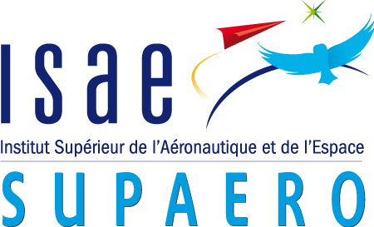

Master of Aerospace Engineering

Research Project

Autonomous Robotic Aerial Vehicle: ARAV Control in Complex Environments

S2 Progress report

Author: Akash Sharma

Due date of report: 06/Apr/2022

Actual submission date: 06/Apr/2022

Starting date of project: 29/Jan/2022

Tutors: Raghuvamsi Deepthimahanthi, Yves Briere

**Table of Contents**

1 Goal of the project 1

2 Project issues 1

3 Main bibliography and State of the Art 2

4 Milestones of the project 2

5 Task 1 3

5.1 Description of Work 3

5.2 Technical Progress 4

5.3 Plan versus achievements 5

5.4 Changes to original plan 5

5.5 Planned work for the next 3 months 5

6 References 6

# Goal of the project

Drones have brought about a technology revolution because of their vast range of applications. These include surveillance, exploration, delivery, topography mapping etc. Ground robots find many uses in space missions for collecting soil samples, analysing the terrain while UAVs (Unmanned Aerial Vehicles) are used to map topography, collect land survey data for infrastructure projects, fertilizer distribution in agriculture etc. Smart robots, capable of carrying out complex tasks without the need for human guidance, called autonomous robots, have also emerged as a dominant piece of technology.

This project aims to design, program and test an unconventional design of an Autonomous Robotic Aerial Vehicle that combines the locomotive modes of ground as well as air, hence, making the vehicle more robust in handling mission trajectories in complex environments on its own.

The vehicle uses sensors and a set of algorithms to carry out different challenges during the mission such as obstacle avoidance, safe landing etc. It is composed of the ground and air modules that activate depending on the decision taken by the vehicle on which path to take.

Within the timeline of one year, the objectives will be the following:

* This project has already been started by previous students. After the completion of their work, several issues related to aerial performance have persisted. In this context, the communication between the ground and aerial modules will be tested on the real vehicle and the flying controller performance will be improved to enable reliable aerial operations.
* A decision-making algorithm will be implemented based on trade-off analysis through which the vehicle is able to make an informed choice about which path to take and what means to use. The vehicle should be smart enough to conserve battery power while avoiding all the obstacles and, at the same time, be able to complete the mission within the time limit.

# Project issues

Several key challenges have been identified that are the main roadblocks to be overcome to deliver the final functional vehicle.

* **Master Algorithm Development:** The main challenge in this project is to bring together all the individual algorithms that function as the intelligence of the vehicle. This decision-making algorithm will allow the vehicle to optimise its functional capability and be able to complete missions more efficiently. The choices between the two modules should be made by the vehicle after taking into consideration optimisation parameters: energy and time. The aerial module would take much less time, but it consumes much more energy, so a trade-off must be made.
* **Module Communication:** Communication between the two modules is also important for the vehicle to understand its overall state. The communication module works well in the simulation, so the same must be tested in the vehicle to validate the results.
* **Weight and PID Tuning Tests:** Another issue to be addressed will be the weight of the vehicle in the context of its aerial performance. The air module is controlled through a PID controller. Currently, the air module has not been tested due to the heavy weight of the vehicle making the PID inadequate in its operation. This issue can be resolved by, possibly, reducing the weight of the vehicle and fine-tuning the PID controller to improve its performance.

# Main bibliography and State of the Art

One of the main objectives of this literature review was to identify decision making algorithms used to optimize the functional capabilities of an autonomous vehicle. These algorithms could be used in the scope of applications other than path selection as well since the idea was to establish their utility. The literature review is also focussed on understanding the simulation environments used to the test stability and control performance of the vehicle pre-flight.

Po-Lung Yu, in his book, Multiple-Criteria Decision Making [1], talks about non-trivial decision making when several criteria are in play. The best decision is made based on a set of alternatives or choices, the outcomes of each of those choices, the set of criteria that are imposed on the decision to be made and finally, the preferences of some outcomes over others.

A decision-making algorithm based on Double Deep Q-Learning with Prioritized Experience Replay has been introduced by Kun Zhang et. al. [2] which is used for autonomous UAV manoeuvring and route guidance.

Rovers and drones are used extensively to scout and explore terrain in remote locations or places with hard accessibility. The most popular examples of exploratory drones and rovers are NASA’s Mars Helicopter, Ingenuity [3] and the rover, Perseverance [4], as well as the Chinese rovers, Yutu and Yutu-2 [5] which have been exploring the Moon in recent years. Scarce but some research of unconventional designs of drones, like ours, has also been carried out by the Aerospace Robotics and Control Lab at Caltech consisting of a bipedal walking and flying robot [6].

# Milestones of the project

Figure 1: Road map of the project (till June)

The milestones for every month are detailed below.

* **February:** The project commenced by getting up to date with the progress made by previous contributors which involves understanding all the individual algorithms that are currently being used in the vehicle and understanding the next objectives. The month was also spent studying ROS (Robot Operating System) and simulation environments used in the project.
* **March:** In this month, a literature review about the existing decision-making algorithms and trade-off analysis tools was conducted. This algorithm would act as the brain of the computer with the capability of executing more sophisticated tasks and analysing its environment autonomously.
* **April:** In this period, the flight PID controller shall be tuned to improve the vehicle flight stability. The vehicle will be tested to be able to hover in one location in space. The weight of the vehicle contributes to the instability of the vehicle as well, so weight reducing solutions will be investigated such as replacing the current battery with a lighter, more efficient one.
* **May:** Once the weight and controller adjustments are made, we will start working on developing the first iteration of the decision-making algorithm. Prior to testing on the vehicle, the algorithm will be tested in the simulation environments for different use cases.
* **June:** Some validation tests will be conducted on the vehicle to discover potential problems and opportunities for improvement. The problem of latency will also be investigated. Since all the control algorithms used coordinate across different platforms like PixHawk, ROS, Raspberry Pi etc, and are, in general, complex algorithms, there is always some latency involved between computation and execution which will hinder the vehicle in making fast computations of decisions and hence, the motion of the vehicle will not be smooth and streamlined.

# Task 1

## Description of Work

The end goal here is to create an **Autonomous Robotic Aerial Vehicle** that makes use of two movement methods to navigate from one place to another without any human guidance. This is made possible by integrating two distinct parts of the vehicle: the air module and the ground module. Several dedicated algorithms act as controllers to govern the motion of the vehicle. The path-planning algorithm works to create intermediate waypoints that the vehicle follows to reach the destination, while the obstacle avoidance algorithm gathers information about the environment through ultrasonic sensors to identify obstacles in the way and controls the vehicle to avoid them. Additionally, there is a safe landing algorithm implemented to ensure the safety of the vehicle while it is either landing on the destination point or switching to the ground module. The general idea of how the vehicle should behave is illustrated below.

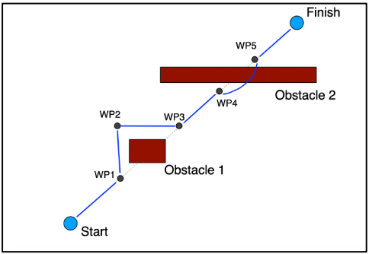

Figure 2: General desired behaviour of the vehicle

The vehicle must not only optimise its path by avoiding obstacles but also through conserving energy and time. A decision-making algorithm based on trade-off analysis of these parameters will enable the vehicle to make the best possible decision based on its complex environment. Decisions will involve choices between using the two modules to cover a given path or navigate past an obstacle. A hybrid model of the vehicle is designed to simulate the operation of all these algorithms which is followed by real time testing on the prototype. The same is shown below.

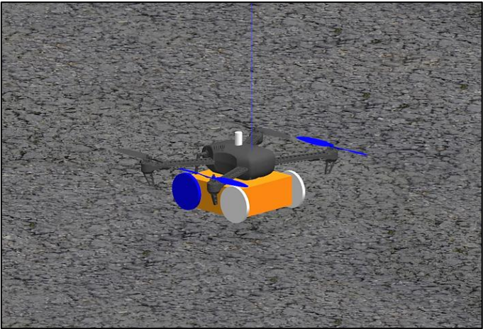

Figure 3: Gazebo Hybrid Model

## Technical Progress

The first objective in this project was to understand its maturity level and the goals. The purposes of the different algorithms in the vehicle were understood to gain an insight into how the vehicle moves. The main simulation platforms for developing these algorithms for robots are ROS and Gazebo and the same are used for this project. Therefore, these environments were thoroughly studied as well. This was followed by a literature review about current decision-making algorithms used in drones and UAVs for various applications.

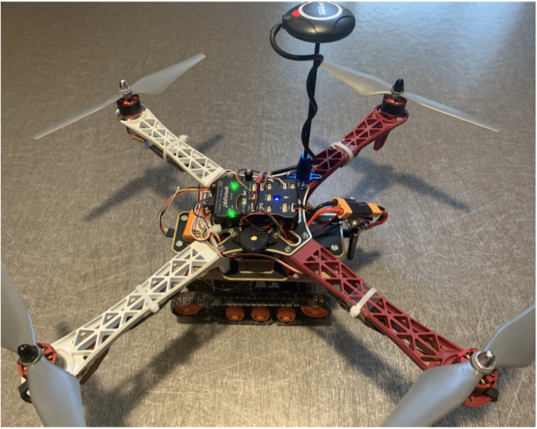The vehicle has been designed and assembled by the previous contributors of the project along with some upgrades being made on certain parts [7][8]. The fully assembled vehicle is shown below.

Figure 4: Fully assembled prototype

Additionally, the path planning as well as the obstacle avoidance algorithms [9] have been developed and tested in the simulation environment.

Two preliminary approaches to a decision-making algorithm have been developed by the previous generation that selects the optimum module between air or ground for a given destination. The first one, named the Path Selector Module [10] calculates a cost function of both potential types of routes that the vehicle can take and selects the one with the lower cost function. The cost function is calculated by multiplying the length of the trajectory with a factor that represents the battery consumption.

The second one, named the communication algorithm [11] selects the trajectory to be taken by the respective modules by looking at the z coordinate of the destination point. A z-value of less than 0.5m triggers the ground module to takeover and follow the ground path.

Currently, we are working on investigating the PID and weight tuning issues that hinder the aerial performance of the vehicle. The next step will be to explore ideas on expanding the two decision control algorithms.

## Plan versus achievements

The first milestone of being familiar with the project technicalities and issues has been reached. The simulation environments used for the hybrid model of the vehicle has also been understood along with conducting a review of existing methods for decision control.

## Changes to original plan

None

## Planned work for the next 3 months

The aerial performance issues in the vehicle will be investigated and corrected. The battery capacity will be improved considering the weight constraints. Simulations and tests will be conducted to validate the corrections. Once the vehicle passes these tests, work will start on developing the main algorithm for decision control.

# References

[1] Yu, Po-Lung, Yoon-Ro Lee, and Antonie Stam. *Multiple-criteria Decision Making: Concepts, Techniques, and Extensions*. 1st Ed. 1985.. ed. 1985. Mathematical Concepts and Methods in Science and Engineering; 30. Web.

[2] K. Zhang, K. Li, J. He, H. Shi, Y. Wang and C. Niu, "A UAV Autonomous Maneuver Decision-Making Algorithm for Route Guidance," 2020 International Conference on Unmanned Aircraft Systems (ICUAS), 2020, pp. 17-25, doi: 10.1109/ICUAS48674.2020.9213968.

[3] “NASA's Ingenuity Mars Helicopter Succeeds in Historic First Flight”, NASA. [Online]. Available : <https://mars.nasa.gov/news/8923/nasas-ingenuity-mars-helicopter-succeeds-in-historic-first-flight/>.

[4] “NASA's Perseverance Rover Begins Its First Science Campaign on Mars”, NASA. [Online]. Available: <https://mars.nasa.gov/news/8963/nasas-perseverance-rover-begins-its-first-science-campaign-on-mars/>.

[5] “First photo of Chinese Yutu-2 rover exploring far side of the moon”. [Online]. Available: <https://www.newscientist.com/article/2189606-first-photo-of-chinese-yutu-2-rover-exploring-far-side-of-the-moon/>.

[6] “A bipedal walking robot that can fly, slackline, and skateboard”. [Online]. Available: <https://www.science.org/doi/10.1126/scirobotics.abf8136>.

[7] S. CHAUDHARY and N. RAGHUNATHAN, “Autonomous robotic aerial vehicle: S3 project report,” March 2019.

[8] A. Sambalov, “Autonomous robotic aerial vehicle: S3 project report”, March 2020.

[9] R. Rodrigues and B. Ismael, “Autonomous robotic aerial vehicle: S3 project report”, March 2021.

[10] J. Bessa and A. Ceballos, “Autonomous robotic aerial vehicle: S3 project report”, March 2022.

[11] K. Mallabadi and R. Dsouza, “Autonomous robotic aerial vehicle: S3 project report”, March 2022.

[12] "Documentation - ROS Wiki", Wiki.ros.org. Available : [http://wiki.ros.org/Documentation](https://docs.px4.io/master/en/development/development.html.).

[13] “PX4 Development | PX4 User Guide”, Docs.px4.io [Online]. Available : [https://docs.px4.io/master/en/development/development.html](https://docs.px4.io/master/en/development/development.html.)